**Business**  **Process** Documentation

**Nusantara Application Certification (NAS)**



|  |
| --- |
| Prepared by: |
| **PT. Nusantara Success Technology**  Jl. Jati Murni No. 30, Jati Padang, Sunday Market  South Jakarta 12540 |



# **Document** version

|  |  |  |  |
| --- | --- | --- | --- |
|  |  |  |  |
| Document Description | 1st Publish |  |  |
|  |  |  |  |
| Document Change history |  |  |  |
| Date | Created by | Verses | Description of changes |
| 27 February 2020 i | WN | 1.1 | NAS versi MVP Mobile Advisor |
|  |  |  |  |
|  |  |  |  |
|  |  |  |  |
|  |  |  |  |
|  |  |  |  |

# **Approval** page

|  |  |  |  |
| --- | --- | --- | --- |
| **PT. Nusantara Sukses Teknologi** | | **Pt. Nusantara Sertimedia Application** | |
| Prepared by: | Approved by: | Review by: | Approved by: |
| Windy |  |  |  |
| Date: | Date: | Date: | Date: |

Nusantara Application Certification

Business Process Documentation

This document is used to describe the workflow and business process of the Nusantara certification application (NAS). Dokumen This document is an Advanced version of the previousversion, namely version 1.1 (Minimum Viable Product) describing the business process of Mobile Asesor

# Flow & Activity Diagram

This section describes the flow/ business processes that occur in the NAS application .

**Flow Diagram in general**

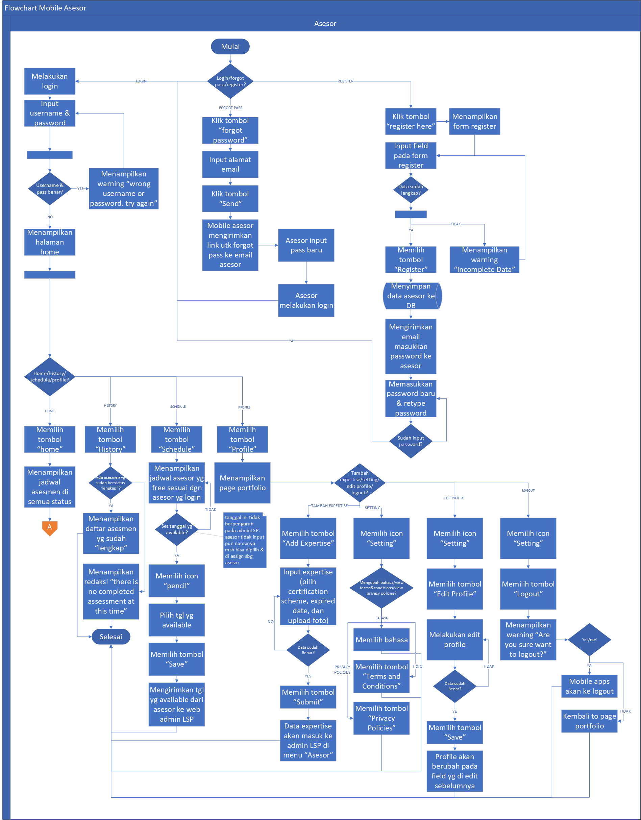

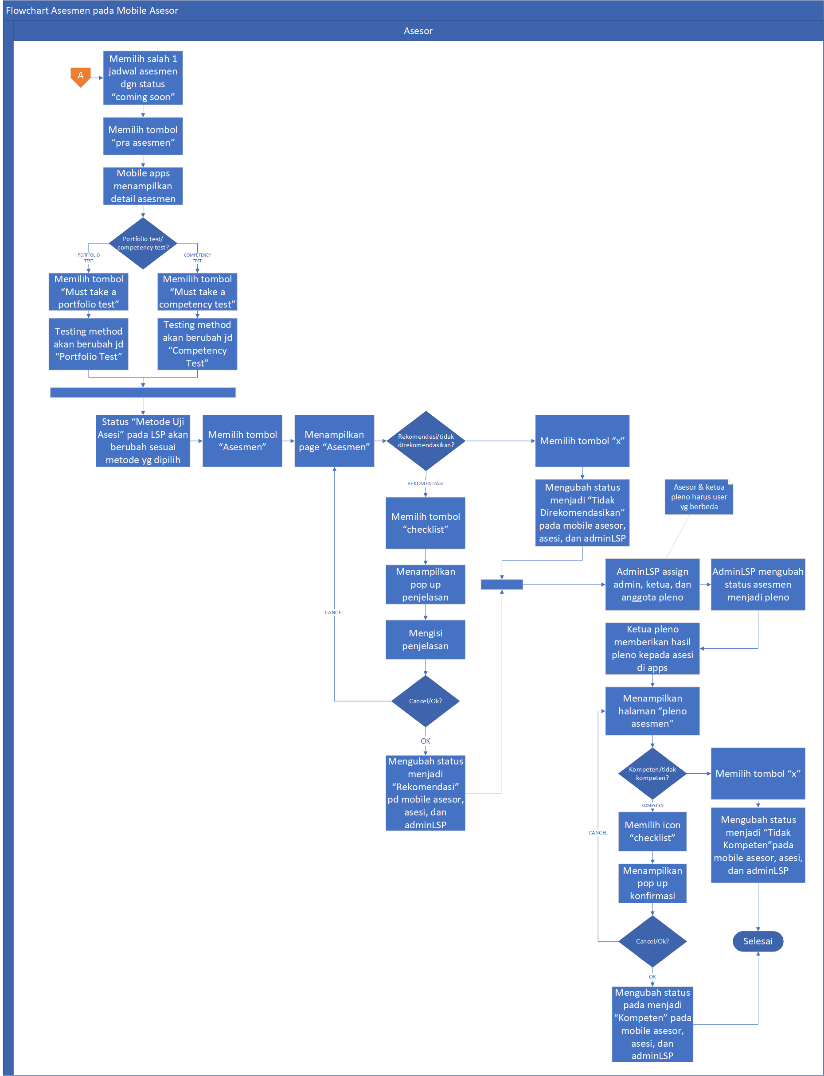

**Activity Diagram NAS Mobile Apps**  **Asesor**  **– "ready**  **pre**  **assessment"**

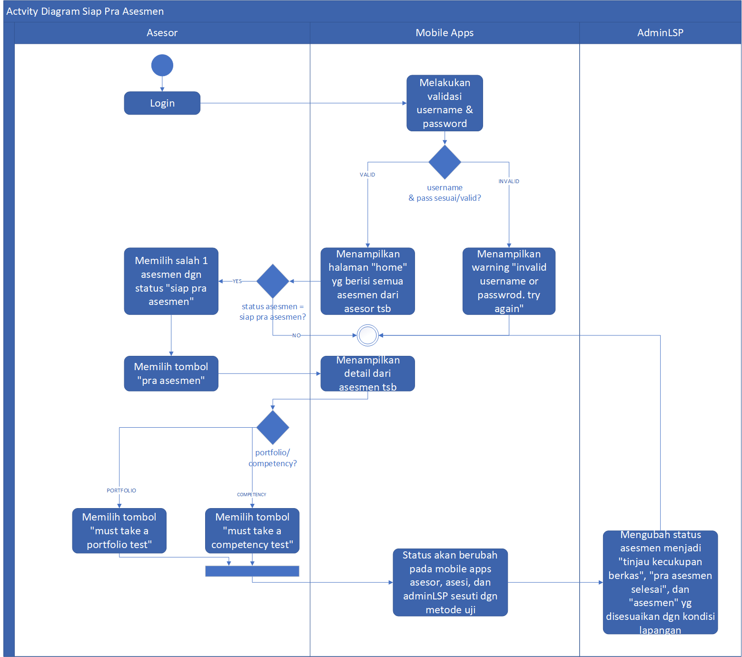

**Activity Diagram Mobile Apps Asesor – “Asesmen”**

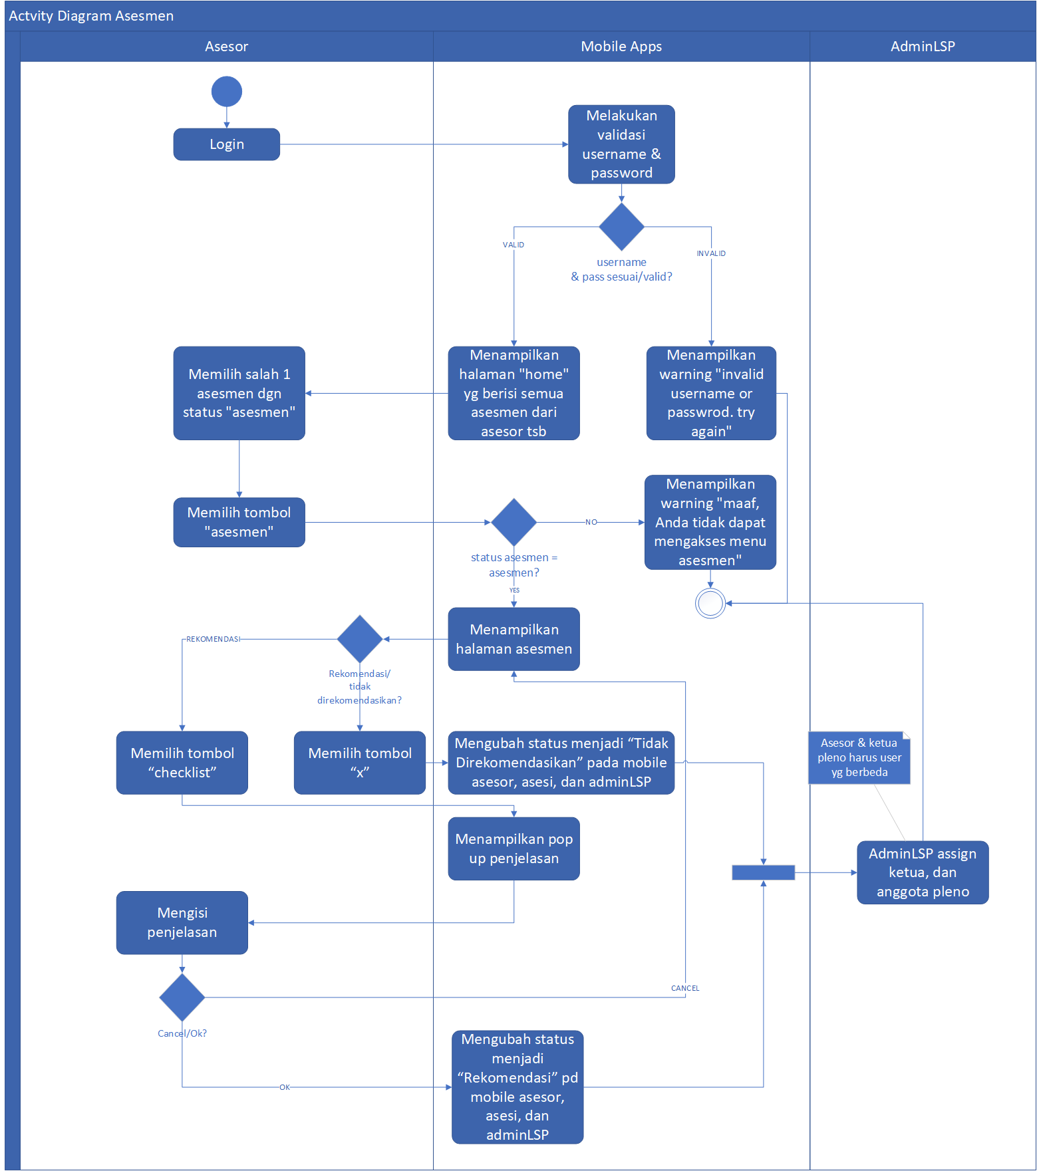

**Diagram Activity Mobile Apps**  **Advisor**  **–**  **"Full"**

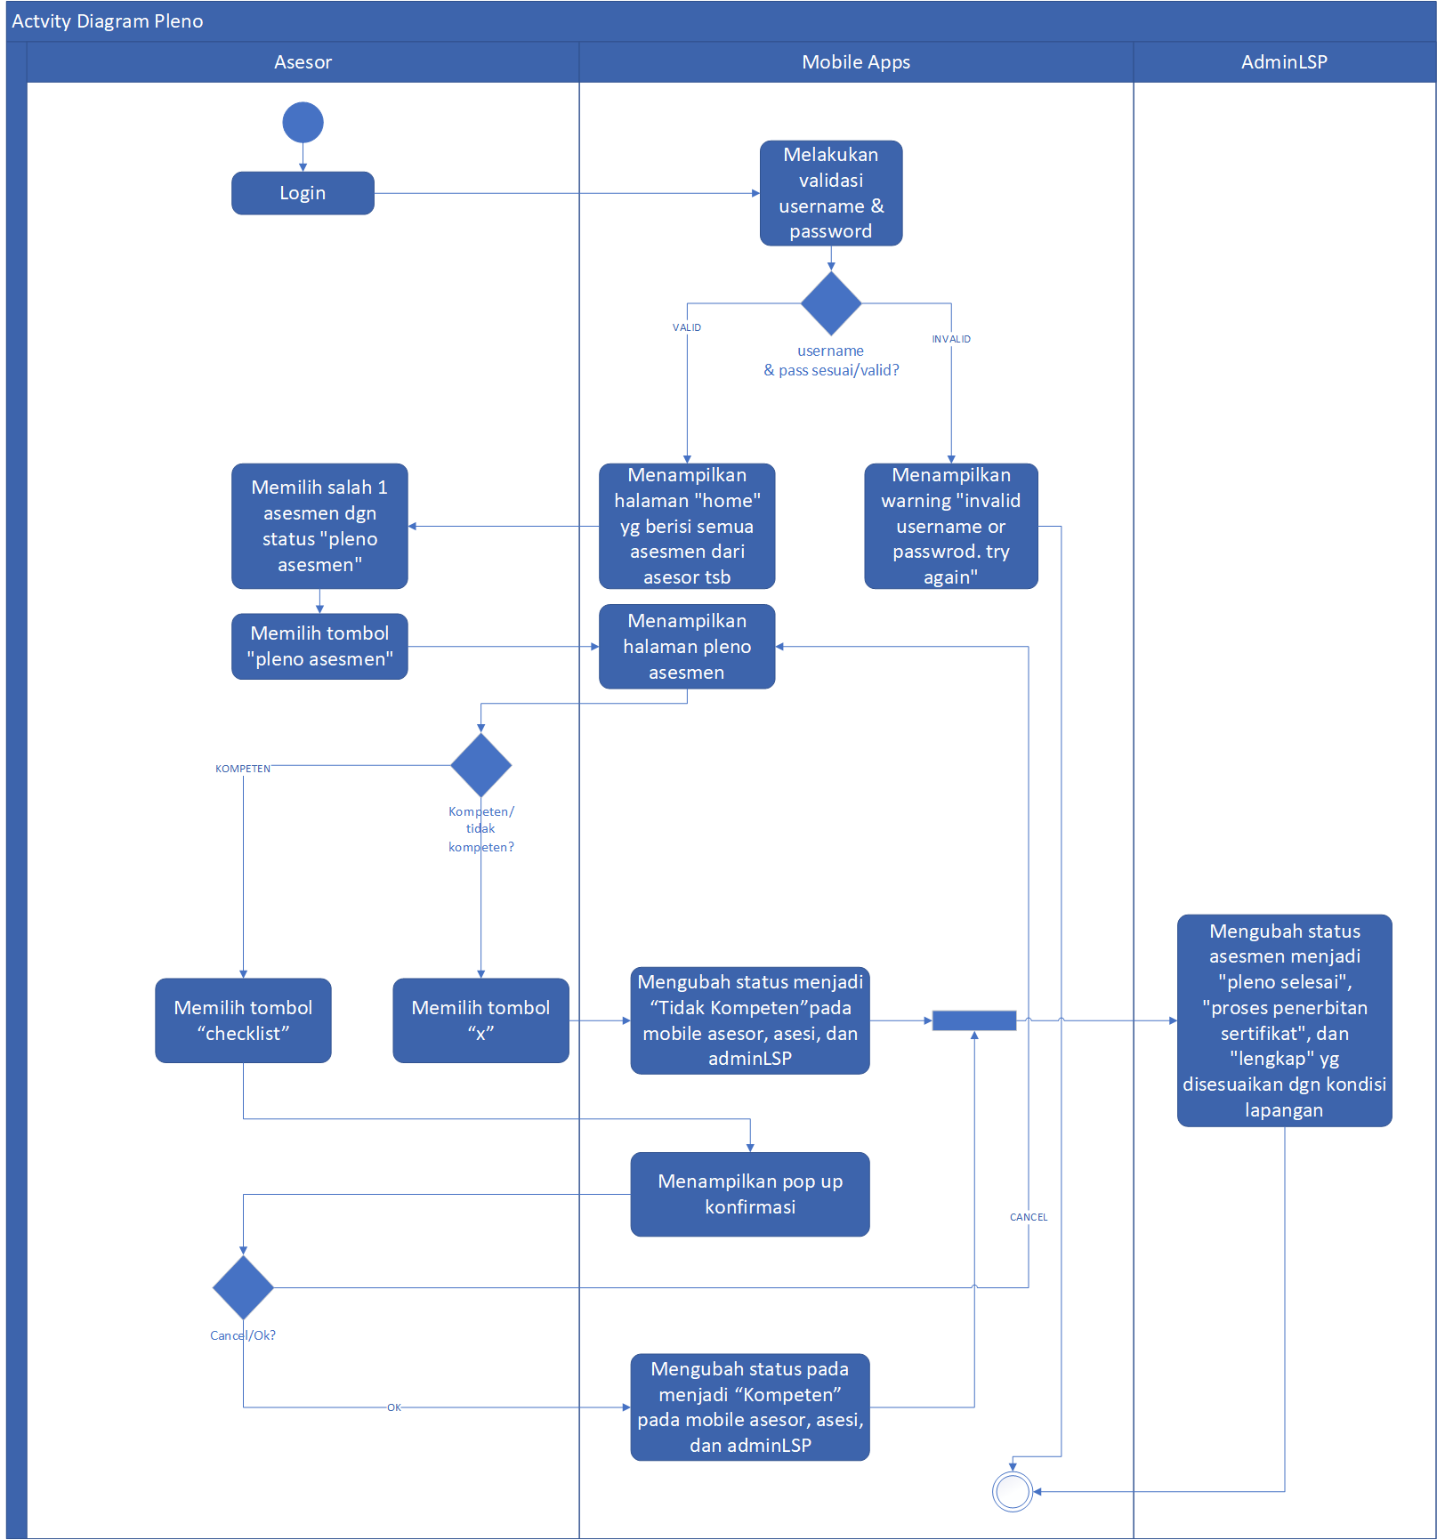

**Activity Diagram Mobile Apps asesor**  **–**  **History Assessment**

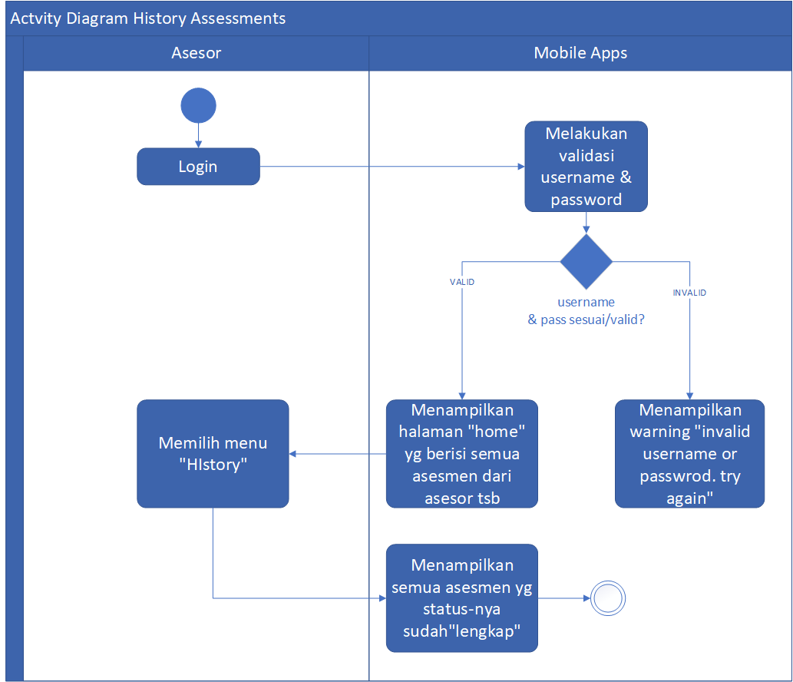

**Activity Diagram Mobile Apps Asesor – Schedules**

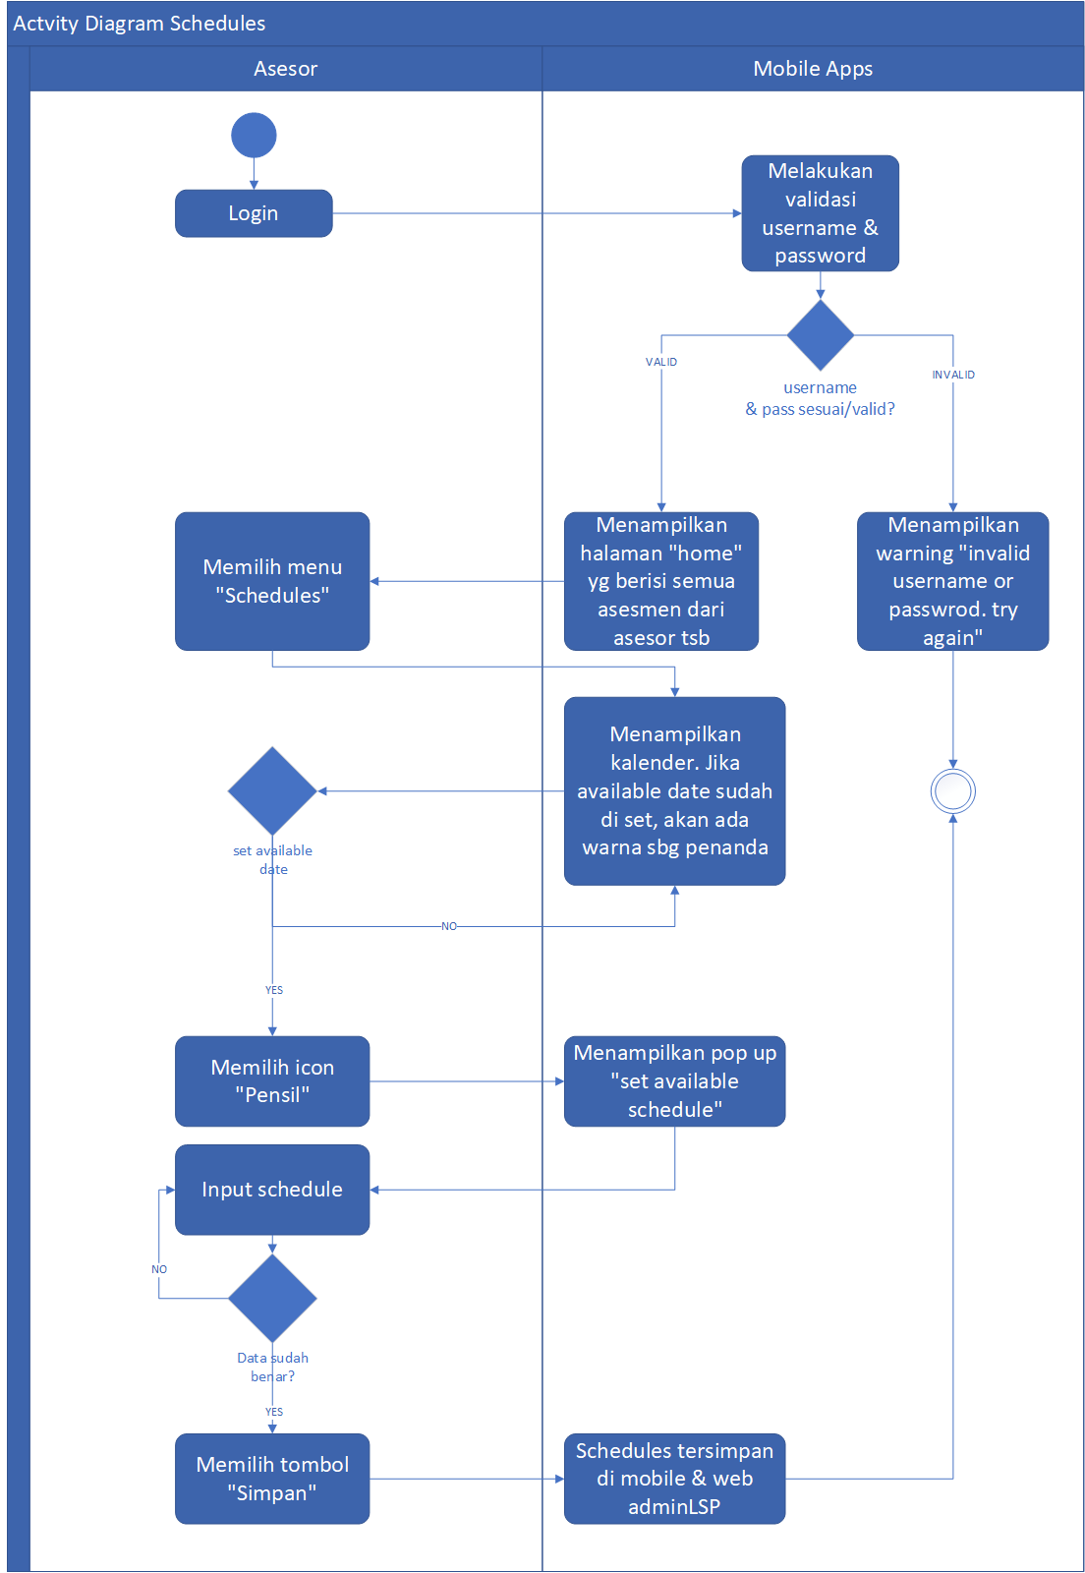

**Activity Diagram Mobile Apps asesor**  **–**  **Input Expertise**

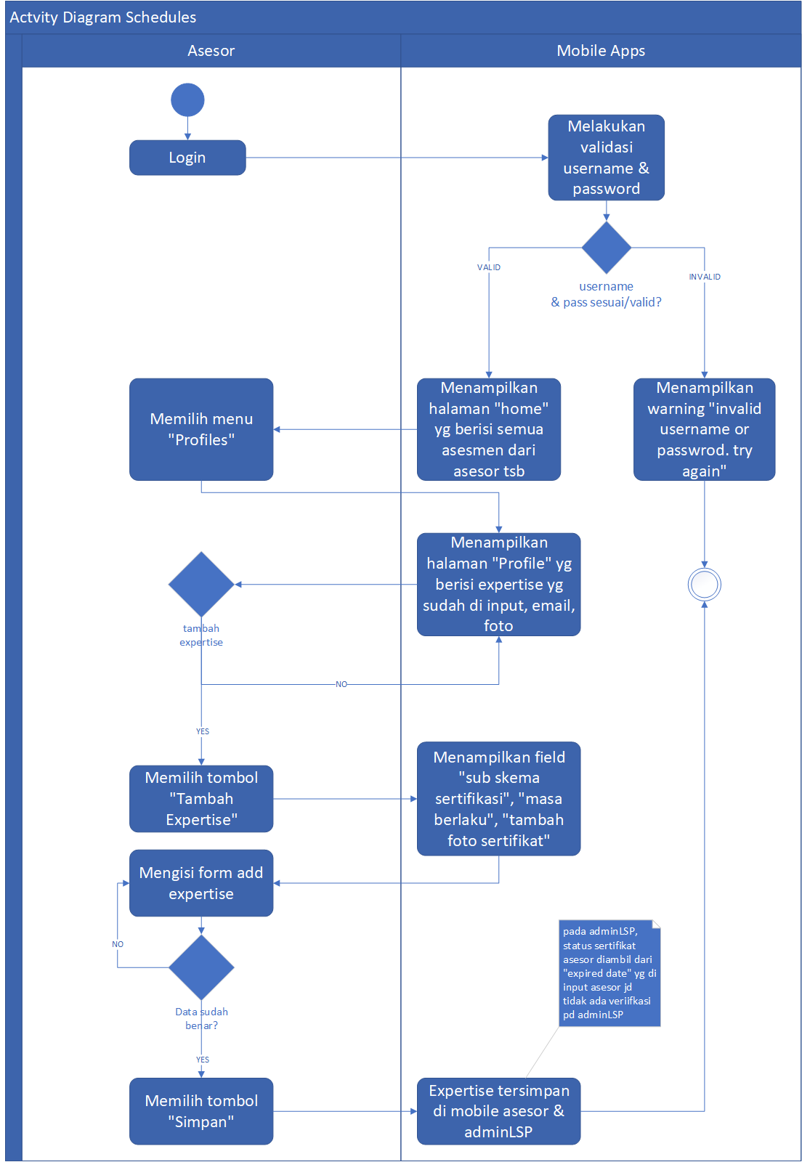

## Description

1. Asesi Login to mobile Assessors
2. Display the "home" page which contains the assessment of the handles by the assessors
3. Asesor Pre- assessment, and assessment for an assessment
4. In assessment status, assessors can choose Competency test or portfolio test
5. At the assessment stage , the assessors can recommend or not recommend
6. If you have reached the tahap Assessmentstage, LSP admins can assign admins, Chairman, and members of the plenary and change the stage of assessment to Plenary. Assessors who have done the assessment, tidak can not be used as the chairman of Plenary
7. When the chairman of the sudah Plenary has given competent or incompetent status , LSP admin can change the status to complete Plenary , penerbitan certificateissuance process, and complete
8. If the status is complete, the assessment will go to the History assessments Menu .
9. Assessors who want to input a blank Schedule can choose the menu "Schedules" and select the "pencil" icon. Jadwal An empty schedule that is already in the input will appear also LSP admin
10. Assessors can input sertifikasi The certification that has been Assessor Get in profile menu and add expertise

## Use Case Diagram

In this section will be described the Authority of each user involved. Here Is the user Permissions chart in the aplikasi NAS Mobile apps Asesorapplication:

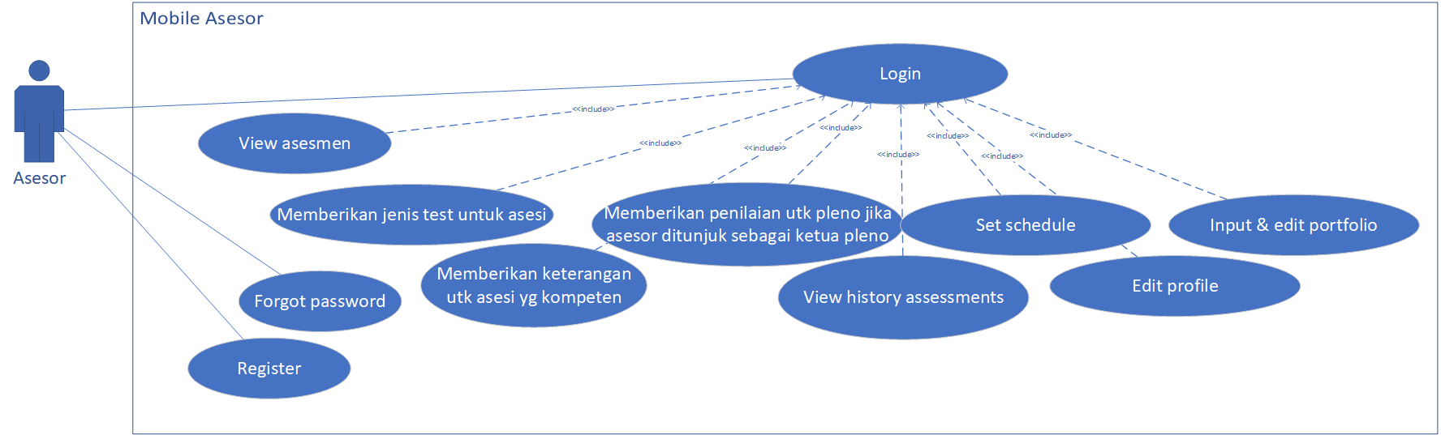

In Mobile Apps, asesor can perform the followingprocess:

1. Login
2. View Assessment
3. Provide a test Method
4. Provide information for competent and
5. Provide Plenary Results if appointed as the chairman of the plenary
6. View history assessments
7. Set available schedules
8. Edit profile
9. Input portfolio
10. Forgot password
11. Register

## Menu List/Features

|  |  |  |  |  |  |  |  |  |
| --- | --- | --- | --- | --- | --- | --- | --- | --- |
| **No** | **Module** | **Sub Modules** | **Sub Sub module** | **Description** | **User** | **Platform** | | **Type** |
| **Advisor** | **Web** | **Mobile** |
| 1. | Login |  |  | This Menu is used to log into the mobile accessories | V |  | V | Validation |
| 2. | Register |  |  | This Menu is used to create an assessor account | V |  | V | Create |
| 3. | Reset Password |  |  | This Menu is used for password reset | V |  | V | - |
| 4. | Home |  |  | This Menu is used to view the assessment with the accessories that are currently logged into mobile apps | V |  | V | View, Update |
| 5. | History Assessments |  |  | This Menu is used to view the assessment of the completed status | V |  | V | View |
| 6. | Schedules |  |  | This Menu is used for date input that is available for | V |  | V | Create, View |
| 7. | Profile | Add Expertise |  | This Menu is used to add a certificate or expertise owned by an assessor | V |  | V | Create, Read, Update, Delete |
| Edit Profile |  | This Menu is used to change the profile details of an assessor | V |  | V | Update, View |
| Settings | Language | This Menu is used to change the language | V |  | V | View |
| Terms and Conditions | This Menu is used to view the Mobile Apps Asesor terms and conditions | V |  | V | View |
| Privacy Policies | This Menu is used to View the privacy Policy | V |  | V | View |
| 8. | Logout |  |  | This Menu is used to exit mobile apps Assessors | V |  |  | - |

## Mobile Design

Here is An example of Design the display aplikasi NAS application on the login Asesor

1. **Login** Page

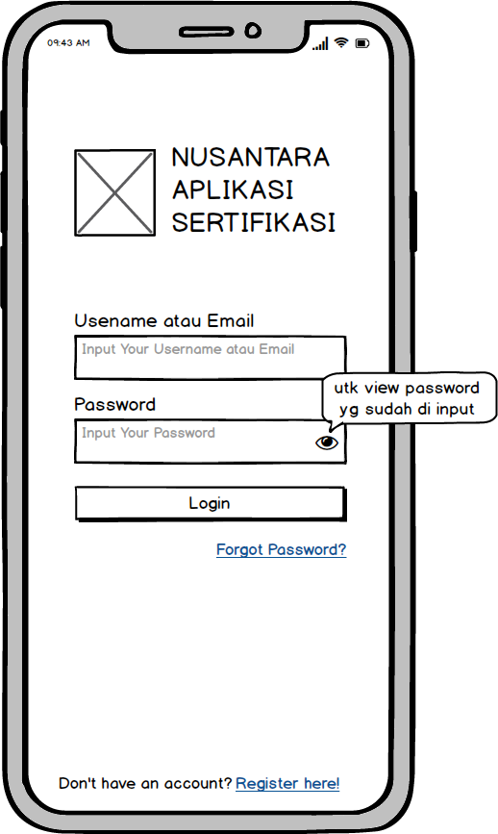

1. **Forgot Password** page

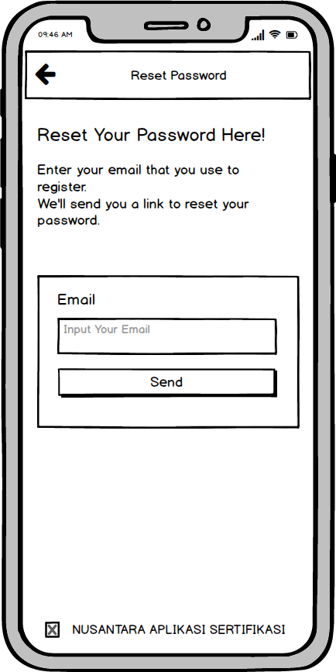

1. **Registration** Page

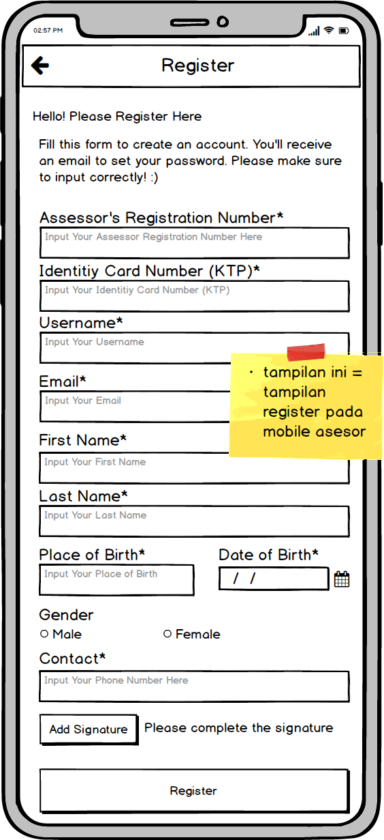

1. **Page Home/home**
2. Home page

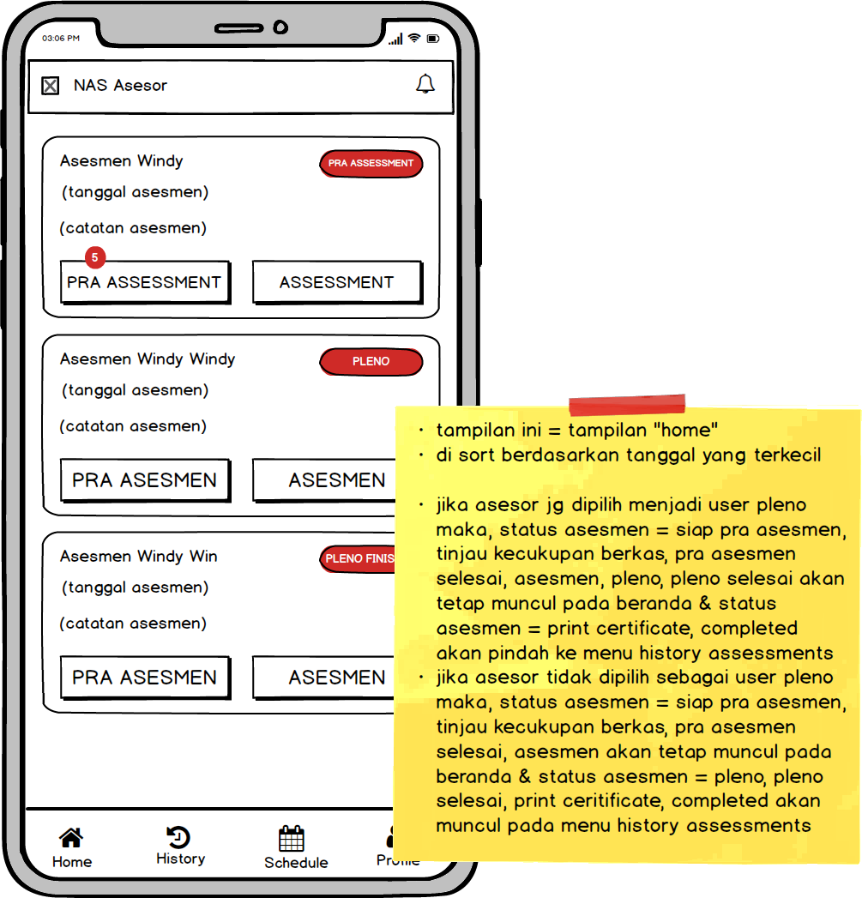

1. Details page

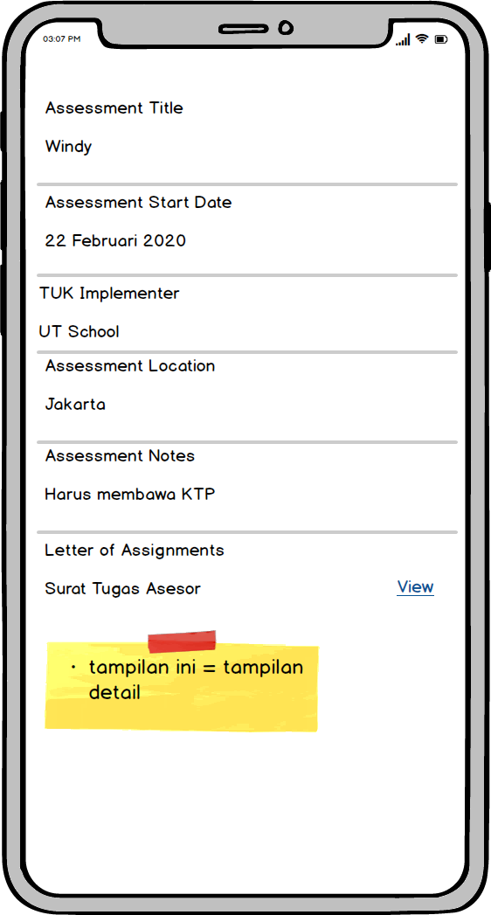

1. **Page pre**  **Assessments**
2. Tampilan Pra Assessments

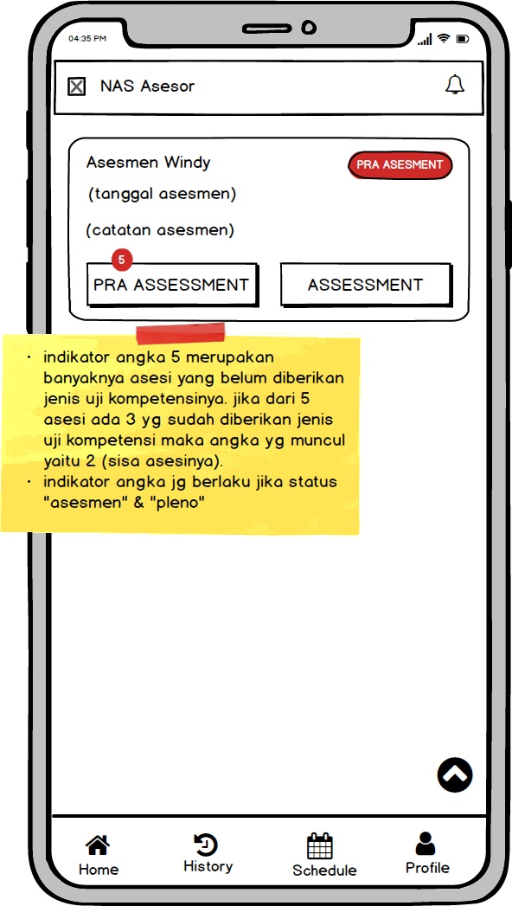

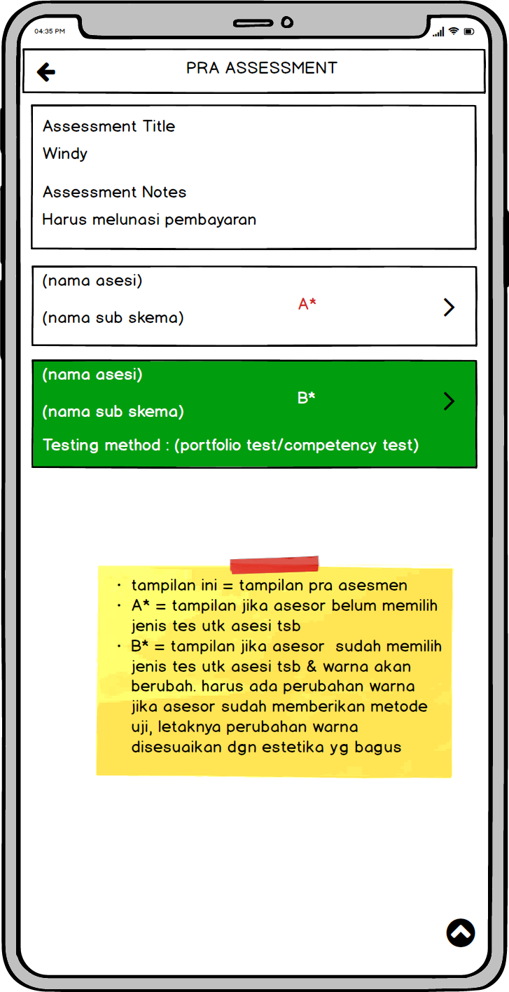

1. Tampilan Detail Assessments

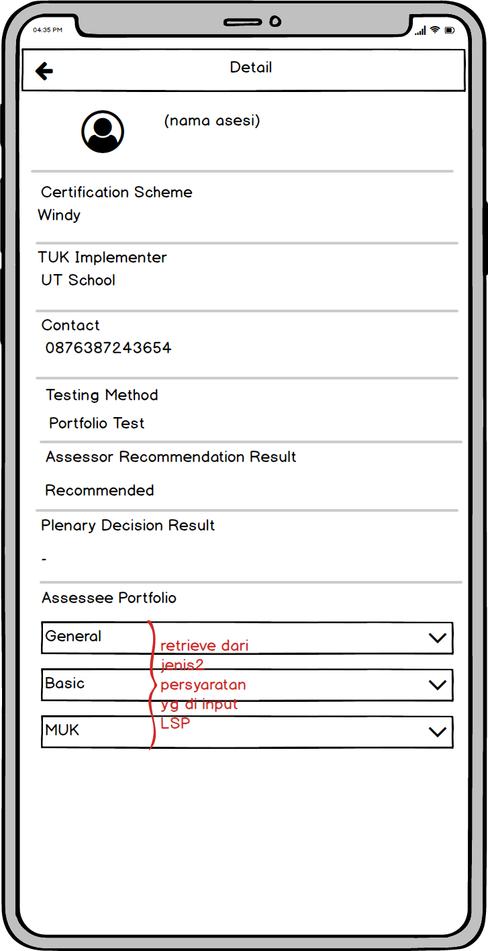

1. **Halaman Assessments**

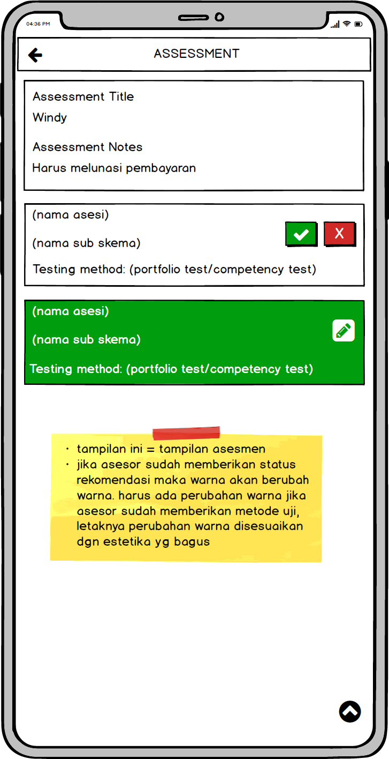

1. **Pleno** page **Assessments**

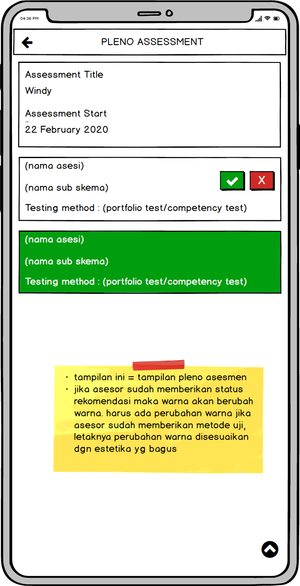

1. **Halaman History Assessments**

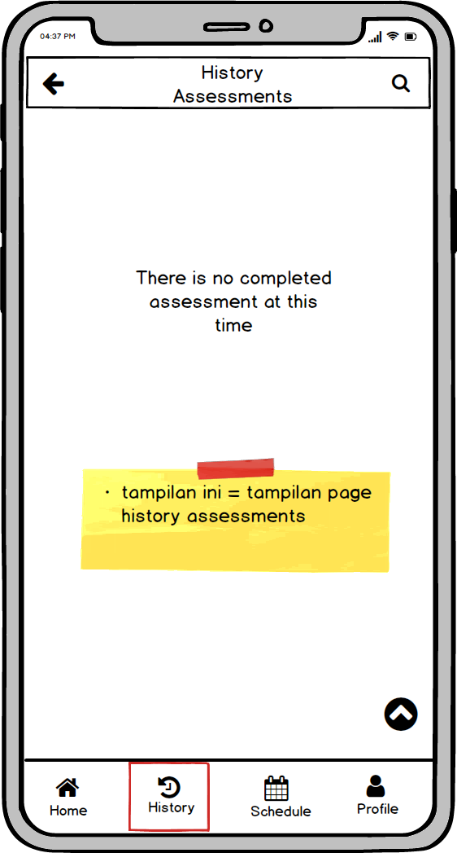

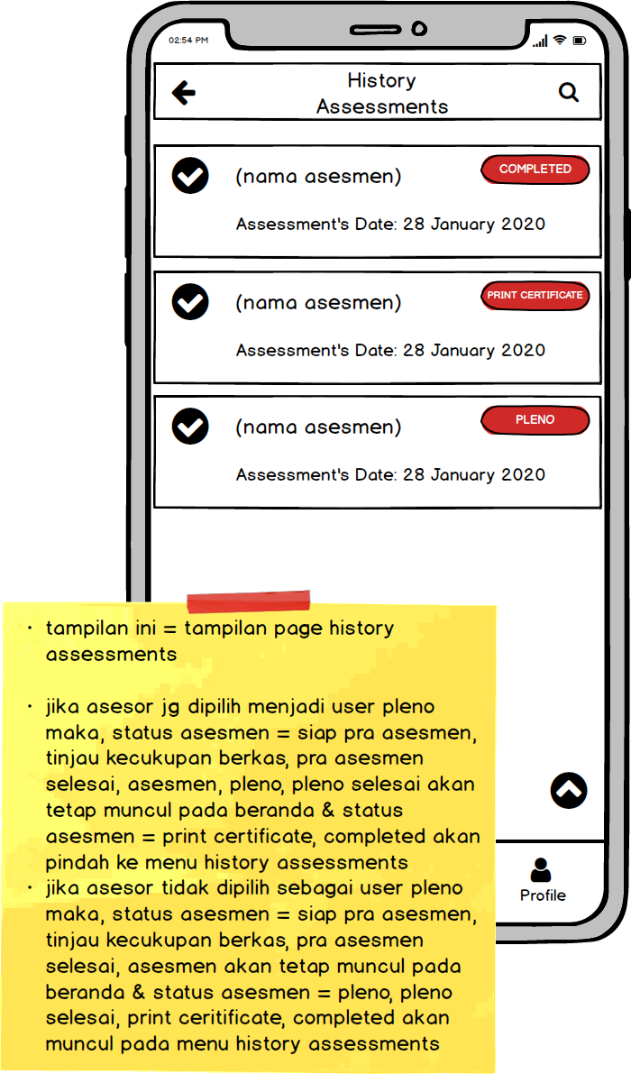

1. **Vegetable Schedules**

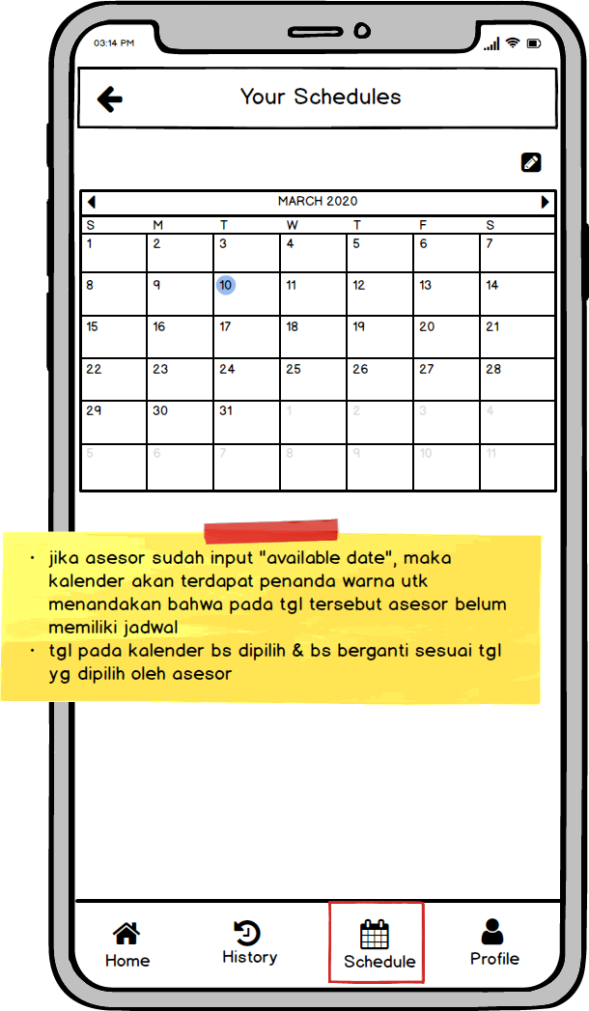

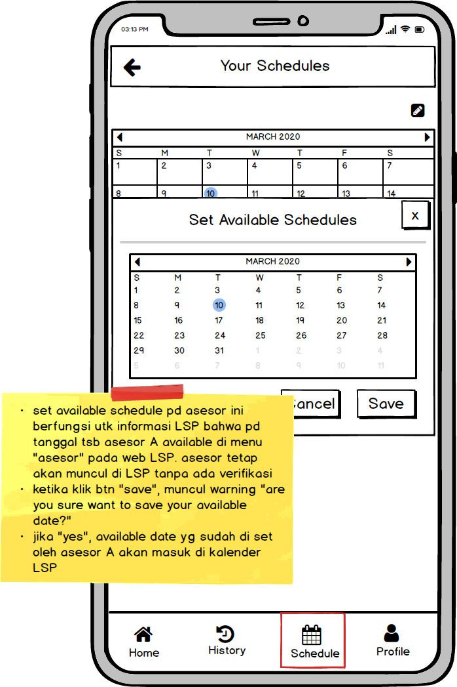

1. **Profile** Page

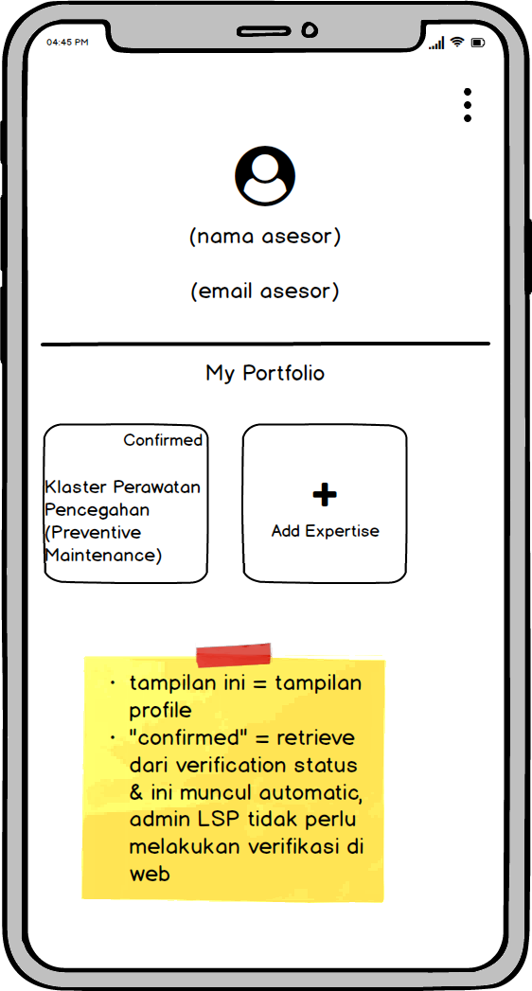

1. **Expertise Detail** page

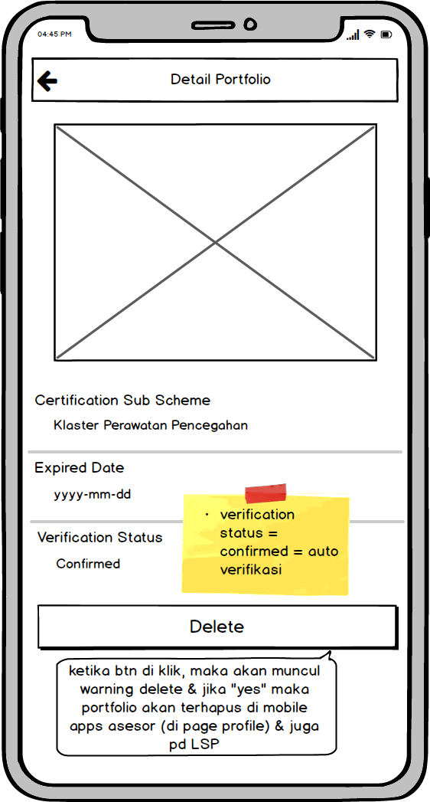

1. **Add Expertise** page

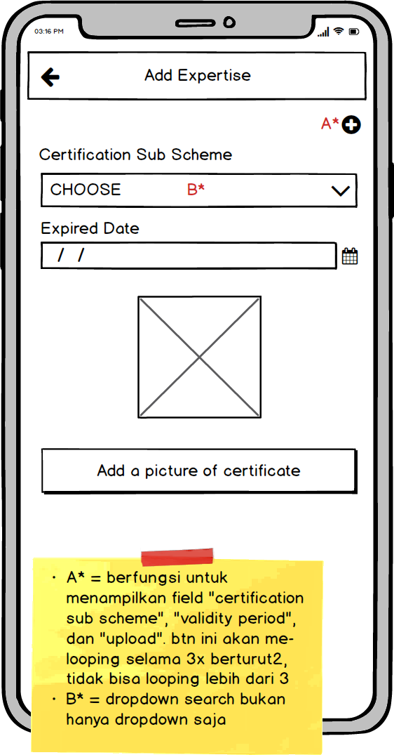

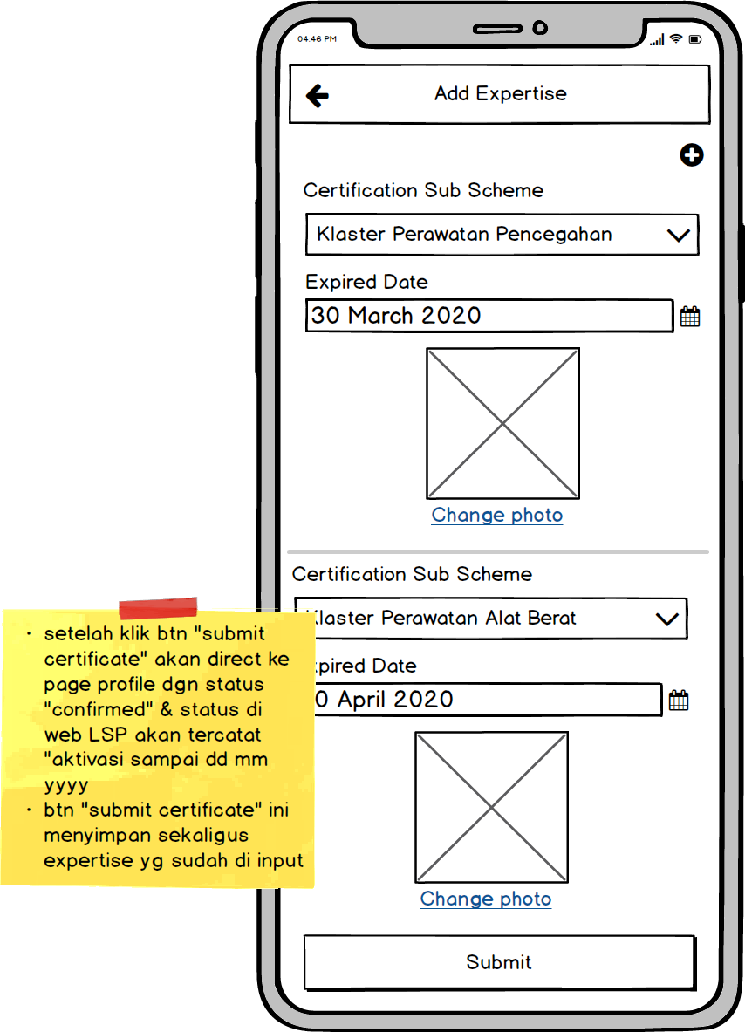

1. **Edit Profile Page**

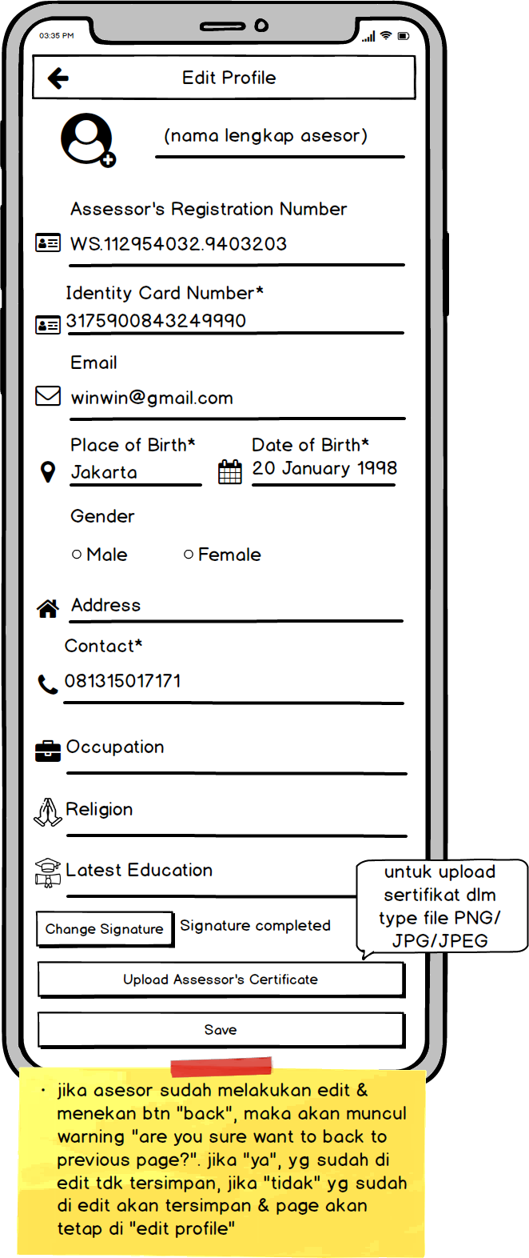

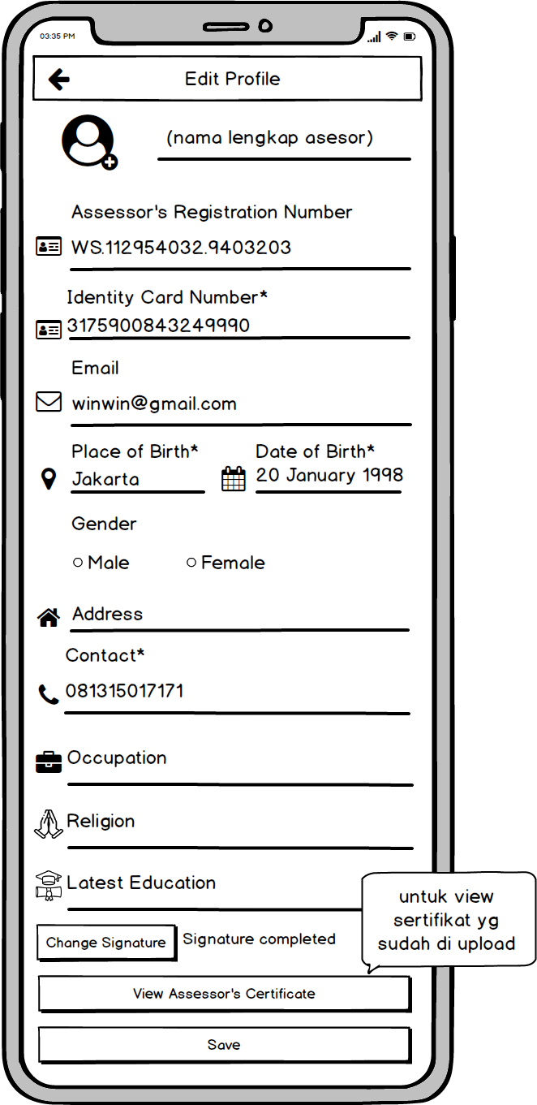

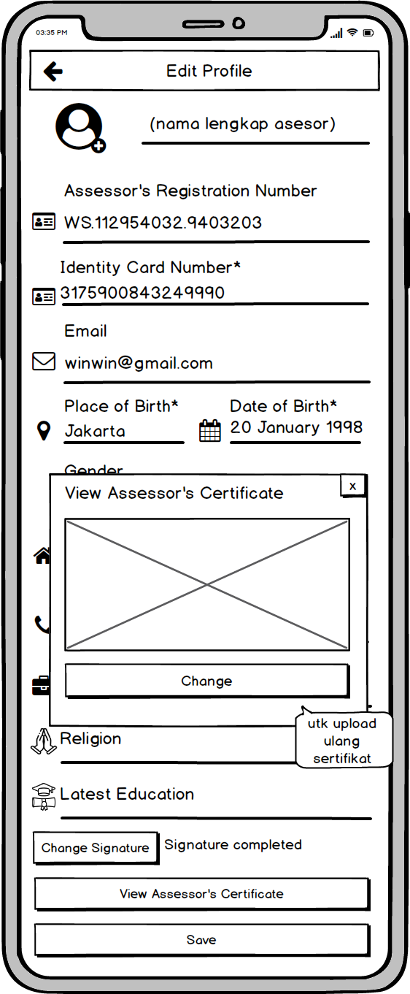

1. **Settings** page

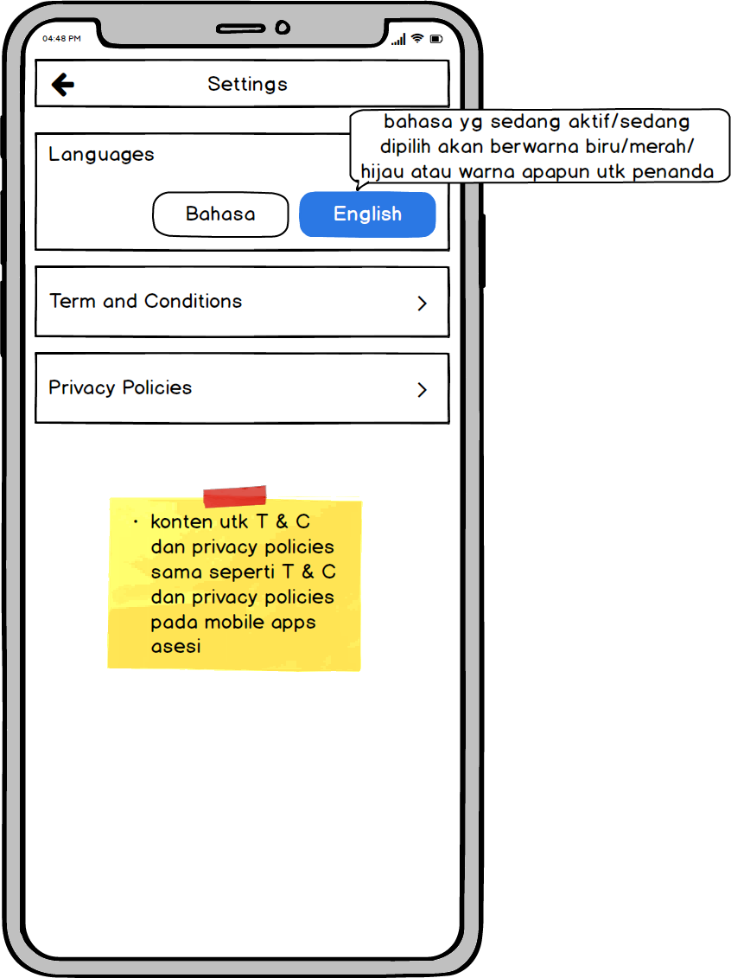

1. **Logout** Page

